**ER-Diagram for Hotel Management System:**

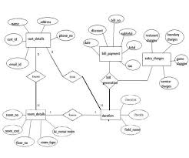

**Process Flow Diagram of Hotel Management System:  
  
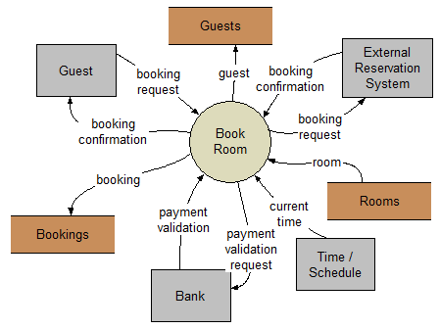**

**Conclusion:** This was a simple effort to create a hotel management program which is able to record the information of guests, hotel staff etc.

I hope you will like it.